“I Second that Emotion.”
EQ: How can we show emotion in a work of art using line?
Procedure:
- Select a picture of a person from a magazine expressing an emotion.
- Cut just that person out and glue to a 9X12 sheet of white or black paper.
- Using only line and patterns to create the emotion the person is expressing with as much detail as possible.
Materials:
9X12 white or black paper
Pencil
Black fine tip perm marker
White Colored Pencil
Metallic Perm Marker
Magazine
Glue
Scissors

GPS:
VA8MC.1a. Uses elements of art and principles of design to expand imagination and develop meaningful ideas.
VA8MC.2d. Explores and invents artistic conventions (e.g., styles, techniques) to connect and express visual ideas.
VA8MC.3 d. Recognizes and evaluates how artists choices (e.g., material selection, techniques, tools, styles, use of visual elements and principles) shape and communicate meaning

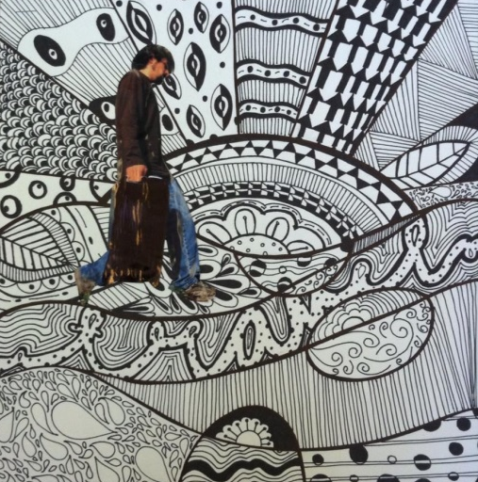
Student Samples:
